**Lab Exercises (Use the following tables):**

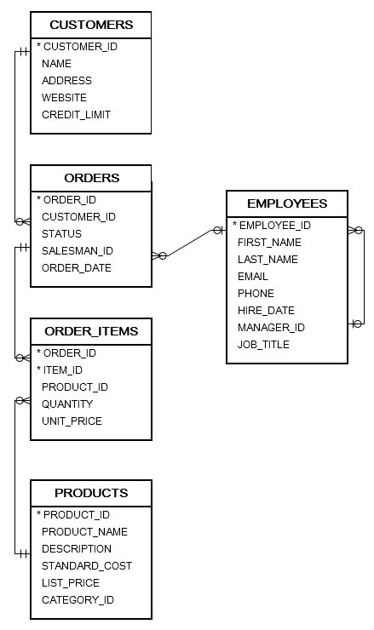

**Use Subquery to find:**

1. **Write a query to display the product id, product_name, list_price for the products that has the list price greater than the product_id 208.**
2. **Write a query to display the name of the products that is ordered more than 6 times.**
3. **Find the employee_id, first name, last name, number of orders for the employees who served the highest number of orders. (note that the salesman_id must not be null).**
4. **Write a query to display the order_id for the ordered items that has quantity more than all quantities inside the order id number 101 and the unit_price is less than the average of unit prices.**

1. **Write a query to display the customer id,name for the customer that ordered an item with unit price=649 and quantity is 139**